**SAP SD Enterprise Structure:**

1. Maintaining Company : T-code – OX15
2. Maintaining Company Code : T-Code – OX16
3. Assign Company to Company Code : T-Code – OX02
4. Maintaining Business Area : T-Code – OX03
5. Maintaining Sales Organization  
   Sales Organization is an organizational unit responsible for the sale of certain products or services.  
   IMG -> Enterprise Structure -> Definition -> Sales and Distribution -> Define, copy, delete, check Sales organization
6. Assigning Sales Organization to Company Code  
   This assignment ensures all the sales made through this Sales Organization are accounted for in the assigned Company Code (Company Code is created by FI Consultant).  
   IMG -> Enterprise Structure -> Assignment -> Sales and Distribution -> Assign Sales Organization to Company Code
7. Maintaining Distribution Channel  
   Distribution Channel is the way, in which Products or Services reach Customers.  
   IMG -> Enterprise Structure -> Definition -> Sales and Distribution -> Define, copy, delete, check distribution channel
8. Assigning Distribution Channel to Sales Organization  
   This assignment ensures, a Sales Organization can supply Materials to Customers through this Distribution Channel.  
   IMG -> Enterprise Structure -> Assignment -> Sales and Distribution > Assign distribution channel to sales organization
9. Maintaining Division  
   Division is a way of grouping materials, products, or services.  
   IMG -> Enterprise Structure -> Definition -> Logistics - General -> Define, copy, delete, check division
10. Assigning Division to Sales Organization  
    IMG -> Enterprise Structure -> Assignment -> Sales and Distribution -> Assign division to sales organization
11. Setting up Sales Area  
    All the sales are made from a particular sales Area. For creating a Sales Order Sales Area is compulsory.  
    IMG ->Enterprise Structure -> Assignment -> Sales and Distribution -> Set up sales area
12. Assigning Sales Organization- Distribution Channel- Plant  
    Plant is created by MM Consultant.  
    IMG -> Enterprise Structure -> Assignment -> Sales and Distribution -> Assign sales organization - distribution channel - plant
13. Define Shipping Points  
    Shipping Point is the Organizational element, which is responsible for shipping the Materials to the Customers.  
    IMG -> Enterprise Structure -> Definition -> Logistics Execution -> Define, copy, delete, check shipping point
14. Assigning Shipping Point to Plant  
    This assignment ensures that goods from different Plant can be dispatched from different Shipping Points.  
    IMG -> Enterprise Structure -> Assignment -> Logistics Execution -> Assign shipping point to plant  
    Note: Ensure to do the under mentioned configuration also though it is not in Customizing node of Enterprise Structure.
15. Defining Common Distribution Channels for Master Data Use  
    The purpose of this activity is to define distribution channels which have common master data..  
    Procedure  
    Access the activity using one of the following navigation options:  
    IMG Menu -> Sales and Distribution -> Master Data -> Define Common Distribution Channels  
    Transaction Code: VOR1
16. Defining Common Divisions for Master DataUse  
    The purpose of this activity is to define distribution channels which have common master data..  
    Procedure  
    Access the activity using one of the following navigation options:  
    IMG Menu -> Sales and Distribution -> Master Data -> Define Common Division  
    Transaction Code: VOR2

SAP SD - Customer & Material Master Data

Master data is one of the key factors in Sales and Distribution module. There are two levels of masters in SD.

The first level master includes −

* Customer Master
* Material Master
* Pricing Conditions

While, the second level master is −

* Output condition

Create a Customer Master Record

The customer master data contains the information about business transaction and how transactions are recorded and executed by the system. A Master contains the information about the customers that an organization uses to do business with them.

Key tables in Customer Master

|  |  |  |
| --- | --- | --- |
| **Table Name** | **Key** | **Description** |
| KNA1 | KUNNR | General Information |
| KNB1 | KUNNR,BUKRS | Company Code |
| KNVV | VKOGRG,VTWEG,SPART,KUNNR | Sales Area |
| KNBK | KUNNR,BANKS,BANKL,BANKN | Bank Data |
| VCNUM | CCINS,CCNUM | Credit Card |
| VCKUN | CCINS,CCNUM,KUNNR | Credit Card Assignment |
| KNVK | PARNR | Contact Person |
| KNVP | VKORG,VTWEG,SPART,PARVW,KUNNR | Partner Functions |

Main Transaction Codes in a Customer Master

|  |  |
| --- | --- |
| **S.No** | **Transaction Codes & Description** |
| 1 | **XD01, XD02, XD03**  Used to create/change/display customer centrally |
| 2 | **VD01,VD02,VD03**  Used to create/change/display customer sales area |
| 3 | **FD01,FD02,FD03**  Used to create/change/display customer company code |
| 4 | **XD04**  Display change documents |
| 5 | **XD05**  Display change documentsUsed to block Customer − Global, order, delivery, billing, sales area, etc. |
| 6 | **XD06**  Used for deletion |
| 7 | **XD07**  Change Account Group |
| 8 | **VAP1**  Create Contact Person |

Creating a Customer Master Data

To create a customer master data, you need to use an Account group.

T-Code: XD01/VD01/FD01

Note that if you use −

* **XD01** − This Includes sales area in the customer master and data is stored in tables KNA1, KNB1 and KNVV.
* **VD01** − This includes sales area & data, which will be stored in tables KNA1, KNB1 and KNVV and there is no company code data in this.
* **FD01** − This is company code level & data is stored in tables KNA1 and KNB1.

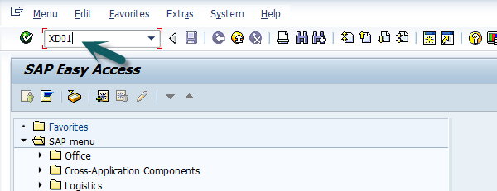

Then a new window will open. Enter the following details −

* Select the Account Group from the list.
* Enter the customer number and select the company code.

Then you can enter the Sales Area details like −

* Sales Organization
* Distribution Channel
* Division

In case you want to take reference from an existing customer to create customer master, you can use the reference option.

Once all the details are selected, click the **Tick** mark.

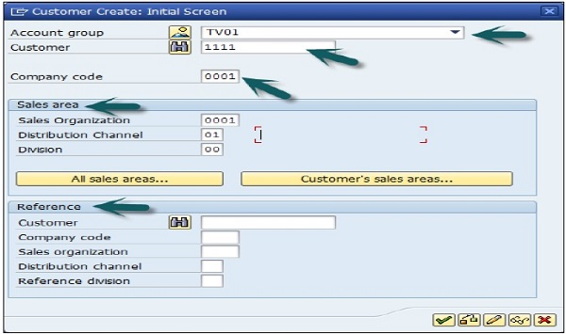

A new window will open to enter the customer master data. This customer master data has 3 key sections −

* General Data like Title, Name, Address, etc.
* Company Code Data and
* Sales Area Data.

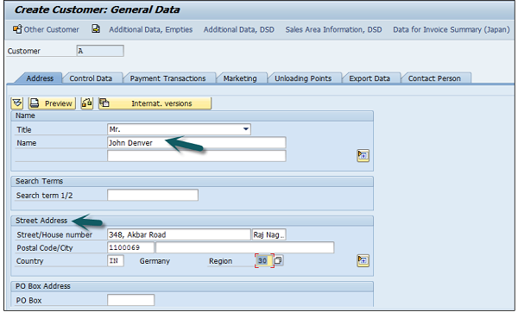

Note that this region fields define the tax calculation like VAT, CST, etc. The next step is to go to Control Data and enter the following details.

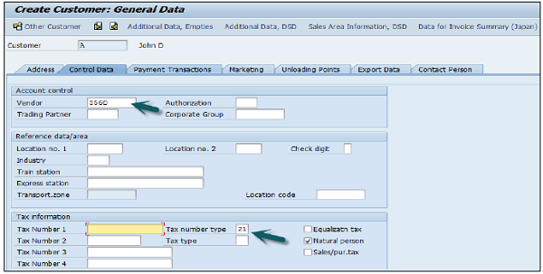

Then you have to enter the particulars in Payment Transaction tab and enter the details of – Bank City, Bank Key, Bank Account and Account Holder Name. You can also add more details by clicking on the Bank data button.

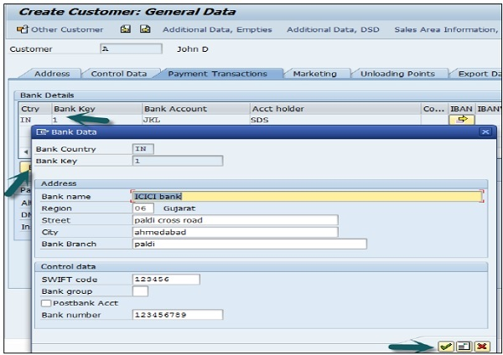

The next step is to go to the Sales Area data and enter the details – Shipping Data, Customer Pricing and Partner Functions, etc.

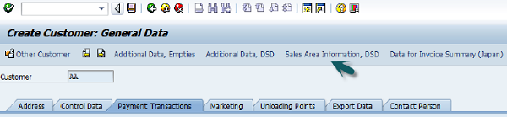

Next is to click on the Save icon at the top and you will get a confirmation that the customer has been created with #.

Saving Icon

If you have to make any further changes to the customer’s master data, you can use **T-Code: XD02.**

AP SD - Create Partner Function

Partner function allows you to identify which functions a partner has to perform in any business process. Consider a simplest case, where all the customer functions are performed by the partner customer. As these are mandatory functions, they have to be defined as obligatory functions in a SD system.

These functions are categorized as per partner type in Sales and Distribution system. The below partner types are Customer, Vendor, Personnel, Contact Person and common partner functions as per these partner types are −

* Partner Type Customer
  + Sold-To-Party
  + Ship-To –Party
  + Bill-To-Party
  + Payer
* Partner Type Contact Person
* Partner Type Vendor
* Forwarding Agent
* Partner Type Personnel
* Employee Responsible
* Sales Personnel

The following tables show the main partner types and their corresponding partner function in Sales and Distribution −

Note that if a partner belongs to a different partner type, in this case you need to create a master records for that partner.

|  |  |  |  |
| --- | --- | --- | --- |
| **Partner Type** | **Partner Function** | **Entry from System** | **Master Record** |
| Customer(CU) | Sold-to Party(SP)  Ship-to Party(SH)  Bill-to Party(BP)  Payer(PY) | Customer number | customer master record |
| Vendor(V) | Forwarding agent(fwdg agent) | Vendor number | Vendor master record |
| Human Resource(HR) | Employee responsible(ER)  Sales Personnel(SP) | Personnel number | Personnel master record |
| Contact Person(CP) | Contact Person(CP) | Contact Partner number | (created in customer master record,no master record of its own) |

Creating a Partner Function

Use **T-Code: VOPAN**

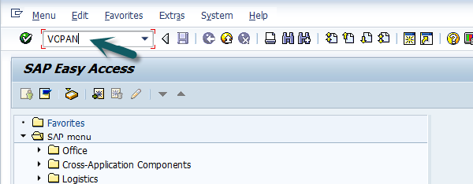

A new window will open. Select the Partner Object and click the Change button.

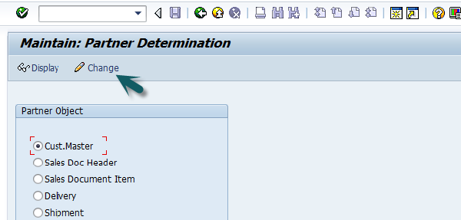

It will open a new window with the name Partner Determination Procedures. Go to New Entries.

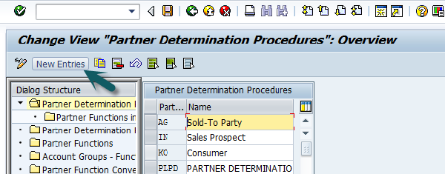

Enter the name and partner determination procedure and double click on Partner Function in left pane.

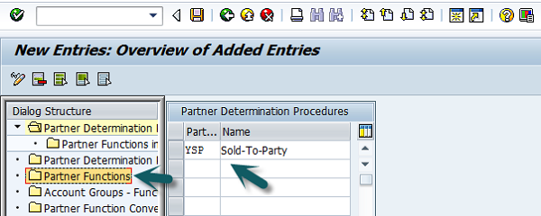

Click the New Entries button.

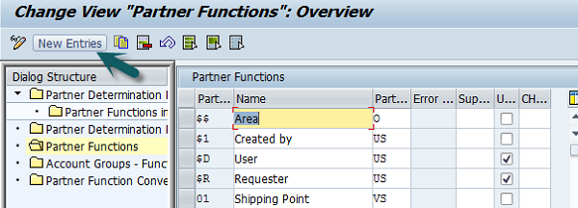

Enter the Partner function details − Name, Type, etc. KU- stands for Customer.

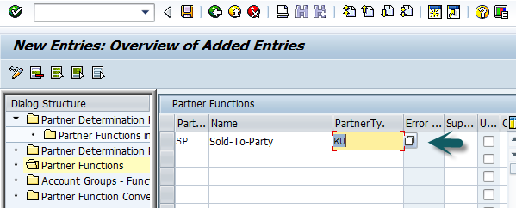

Next is to click on the Partner Function under Partner Determination Procedure node and enter the details Partner Det. Procedure, Name, Partner Function.

Then, we need to assign this partner determination procedure to the Partner Object. The Partner Object would be a Customer for this example. Then Click on Account Groups and Select the Account group name from the list. Once it is done, Click **Save**, it will save the partner function.